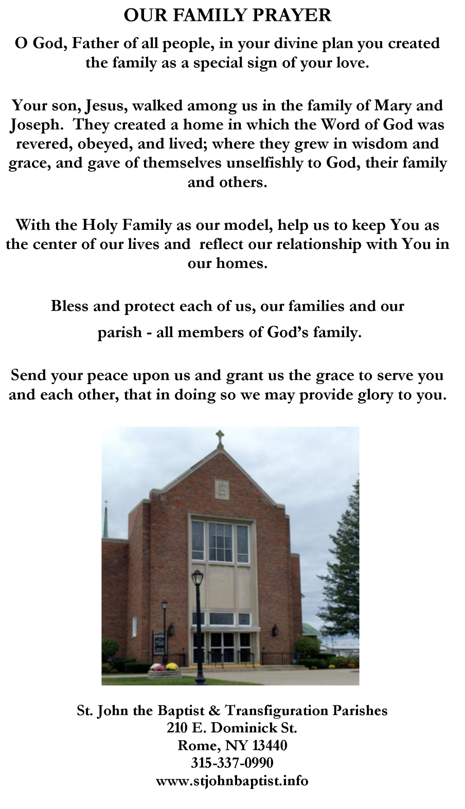

About your loved one…

Name

Date of birth-Date of death

**IN LOVING MEMORY OF**

**Placing of the Pall**

**Placing of the Christian Symbol**

**Entrance Song**

**Words of Remembrance**

**First Reading**

**Reader**

**Responsorial**

**Second Reading**

**Reader **

**Gospel**

**Homily**

**General Intercessions**

**Response:** Lord, hear our prayer.

Pall Bearer/Family Member

Pall Bearer/Family Member

**Preparation of the Gifts**

**Our Father** Sung

**Communion Hymns**

**Signing of the Book of Life**

**Final Commendation**

**Celebrant**

**Main Con-celebrants**

**Music Minister**

**Pall Bearers**

Pall Bearer/Family Member

Pall Bearer/Family Member

‘

‘

/

‘/p